LAB EXPERIMENT 11
NAME:Furthose samreen B
REG NO:192511164
11. Create a Static Website and Containerize, Build & Serve it using Docker. Tasks: 1. Create a Simple Static Website (index.html file) with basic HTML content. 2. Write/create a Dockerfile to serve the website using Nginx. 3. Build the Docker Image 4. Run the container: 5. Access the Website using a Browser
1. AIM
To create a simple static website using HTML, write a Dockerfile to serve the website using the Nginx web server, build a Docker image, run the container, and access the website through a web browser.
2. PROCEDURE
Step 1: Create a Static Website
- Create a new folder named static-website.
- Inside the folder, create a file named index.html.
- Write basic HTML code to display a webpage.
Step 2: Create Dockerfile
- Create a file named Dockerfile inside the same folder.
- Add the following instructions:
- 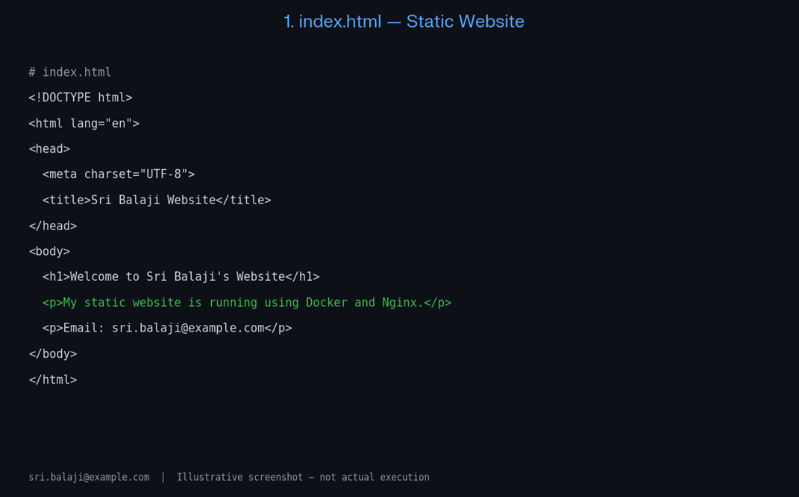
- 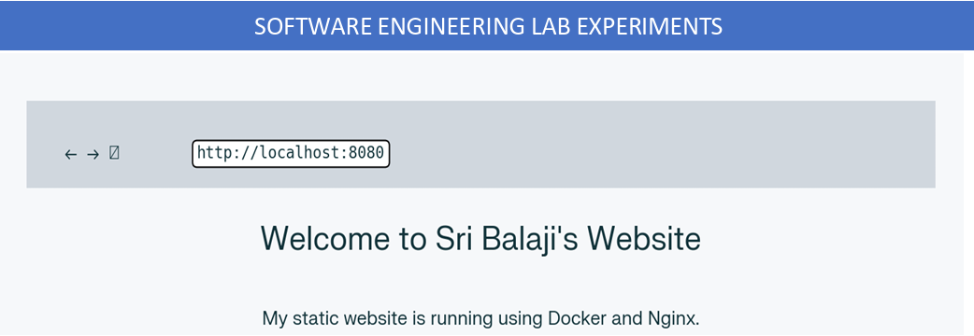

LAB EXPERIMENT 12
NAME : Furthose samreen B
REG NO:192511164
12. Create a Simple Python Flask API, Containerize the Application, Build & Push the Image using Docker and Deploy the Application using Kubernetes. Tasks: 1. Create a Simple Flask API by writing a Python file (app.py) with basic endpoints. 2. Containerize the Flask App using Dockerfile. 3. Build the Image using Docker. 4. Push the Image to Docker Hub. 5. Create Kubernetes manifests (Deployment YAML & Service YAML) to deploy the application.
1. AIM
To create a simple Python Flask API with basic endpoints, containerize the application using Docker, build and push the Docker image to Docker Hub, and deploy the application using Kubernetes.
2. PROCEDURE
Step 1: Create a Simple Flask API
- Create a folder named flask-app.
- Inside the folder, create a Python file named app.py.
- Write the following code:
- 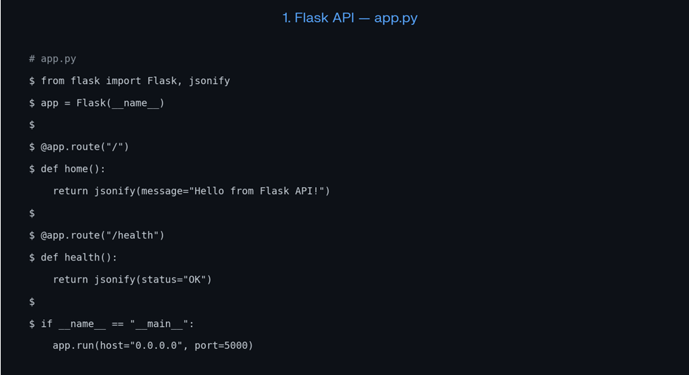
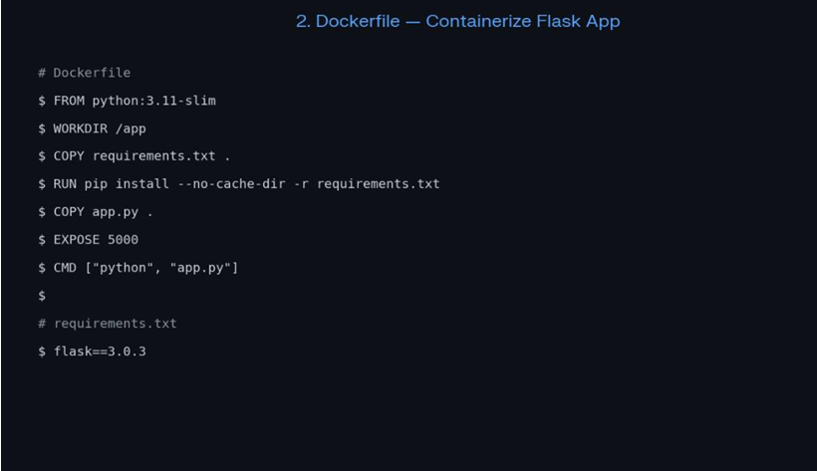
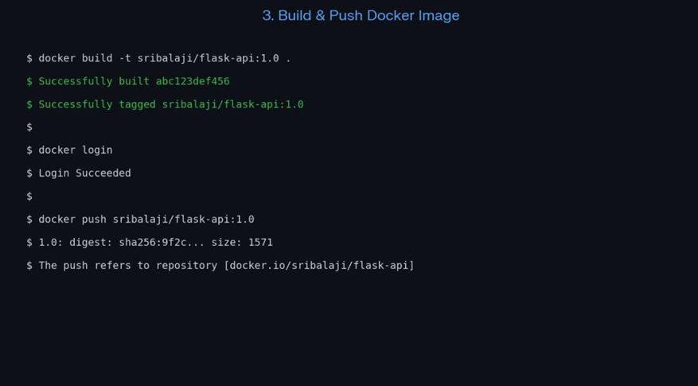

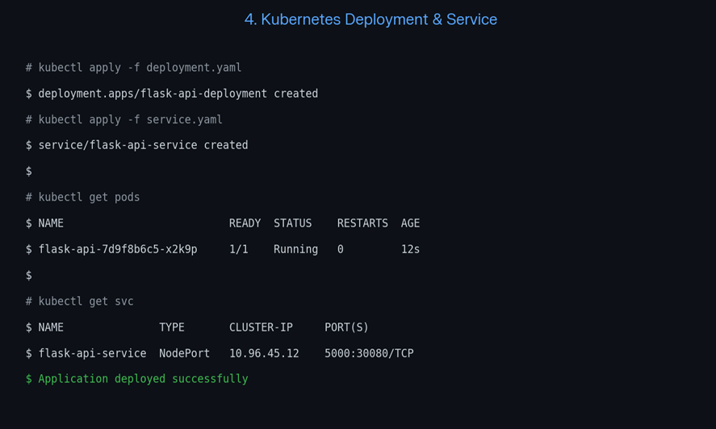
RESULT
Thus, a simple Python Flask API was successfully created, containerized using Docker, built and pushed to Docker Hub, and deployed using Kubernetes with Deployment and Service YAML files.

LAB EXPERIMENT 13
NAME:Furthose samreen B
REG NO:192511164
13. Set up a CI/CD pipeline to automate the building, testing, and deployment of a containerized application. Tasks: 1. Set up Jenkins on a local machine or server. 2. Create a Dockerfile to containerize a sample application. 3. Write a Jenkinsfile to automate the process of building the Docker container, running tests, and deploying to a cloud platform (e.g., AWS or GCP). 4. Configure Jenkins to trigg`er builds upon code commits or pull requests.
1. AIM
To set up a CI/CD pipeline using Jenkins to automate the process of building, testing, and deploying a containerized application using Docker. The pipeline is configured to trigger automatically whenever code changes are committed or pull requests are created.
2. PROCEDURE
Step 1: Set Up Jenkins
- Download and install Jenkins on the local machine.
- Open Jenkins in a browser using:

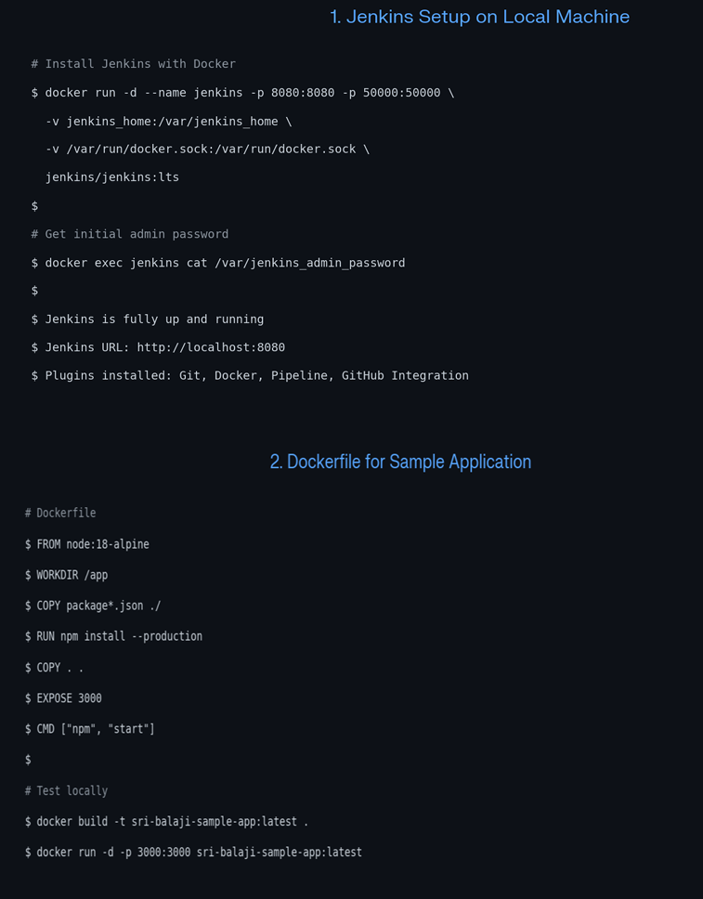
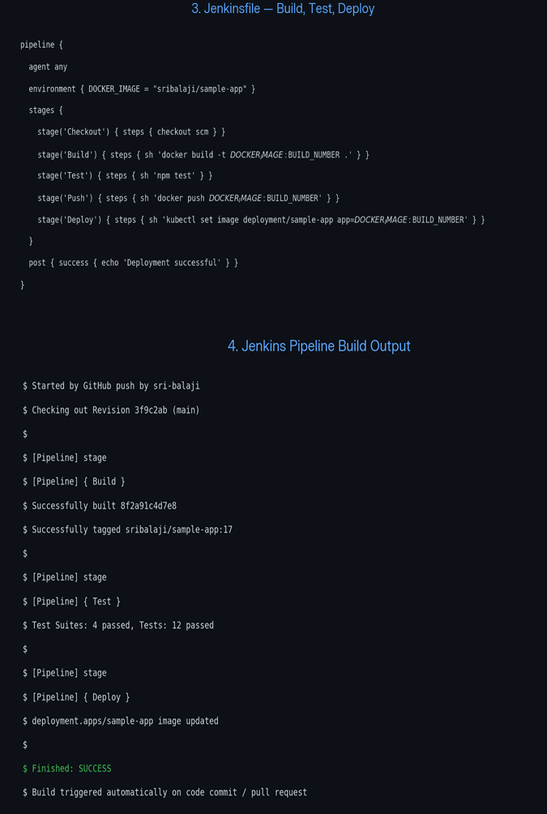
RESULT
Thus, a CI/CD pipeline was successfully configured using Jenkins and Docker to automate application building, testing, and deployment. Automatic build triggering was configured using GitHub integration, reducing manual effort and improving software delivery.
Note: The given Jenkinsfile demonstrates the Build and Test stages. The Deploy stage currently displays a message; actual AWS or GCP deployment requires cloud credentials and deployment commands.

LAB EXPERIMENT 14
NAME:Furthose samreen B
REG NO:192511164
1. AIM
To implement Continuous Deployment using GitHub Actions to automatically build and push a Docker image to Docker Hub and deploy the Dockerized application to a cloud platform whenever new code changes are pushed to GitHub.
2. PROCEDURE
Step 1: Create a GitHub Repository
- Open GitHub.
- Login to your GitHub account.
- Click on New Repository.
- Enter the repository name as docker-cd-project.
- Click Create Repository.
Step 2: Create a Simple Application
- Create a file named app.py.
- Add the following Python code:
- 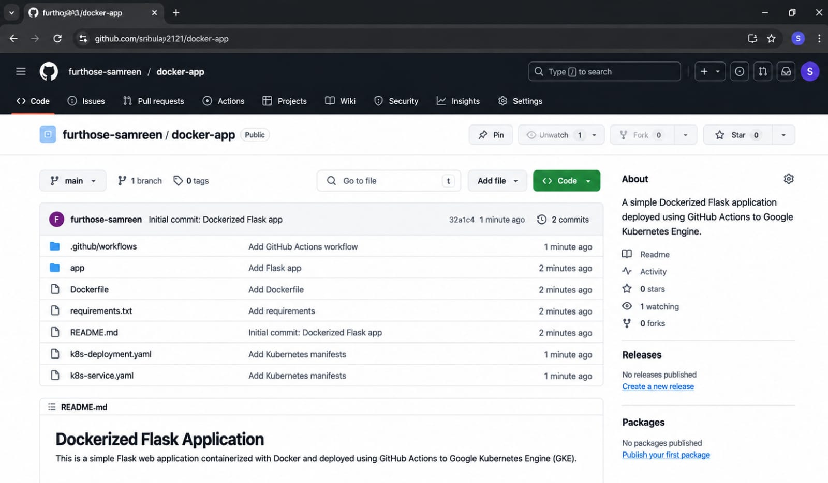
- 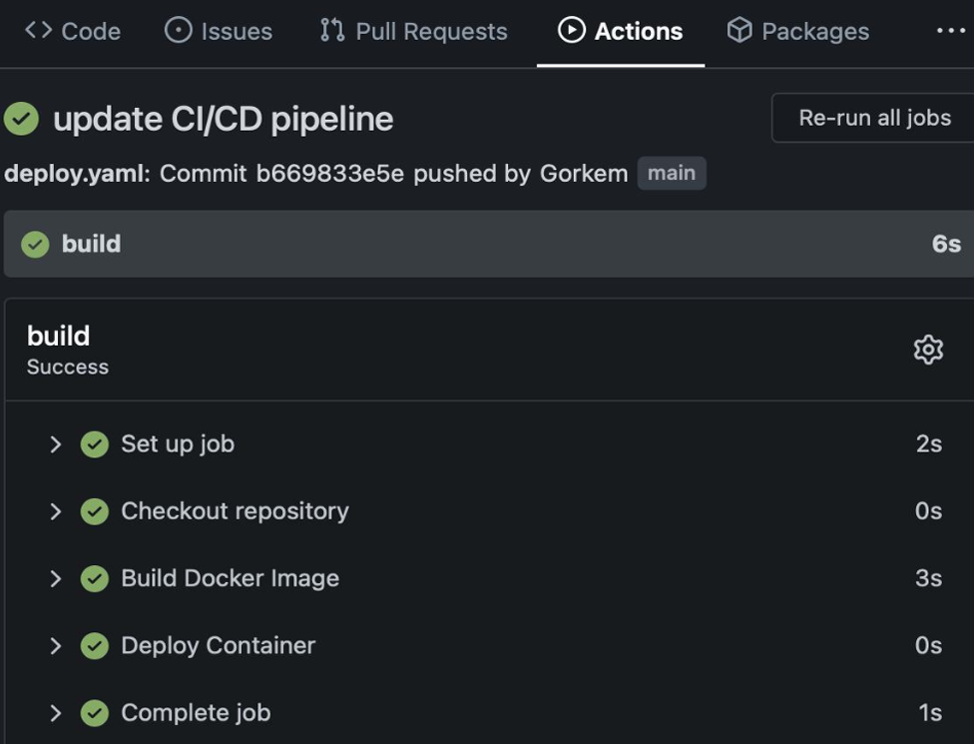
- RESULT
- Thus, Continuous Deployment was implemented using GitHub Actions to automatically build and push a Docker image to Docker Hub whenever code changes were pushed to GitHub. The workflow was configured for cloud deployment, enabling automated application updates and reducing manual deployment effort.
- Note: The given workflow automates Docker image building and pushing to Docker Hub. Actual AWS, Azure, or GCP deployment requires additional cloud credentials and deployment steps.

LAB EXPERIMENT 15
NAME:Furthose samreen B
REG NO:192511164
1. AIM
To create a GitHub repository for a team project and implement version control using branches, commits, pull requests, code reviews, and conflict resolution. Also, document the project workflow using a README file.
2. PROCEDURE
Step 1: Create a GitHub Repository
- Open GitHub.
- Login to your GitHub account.
- Click on New Repository.
- Enter the repository name as Team-Project.
- Select Public or Private.
- Click Create Repository.
- 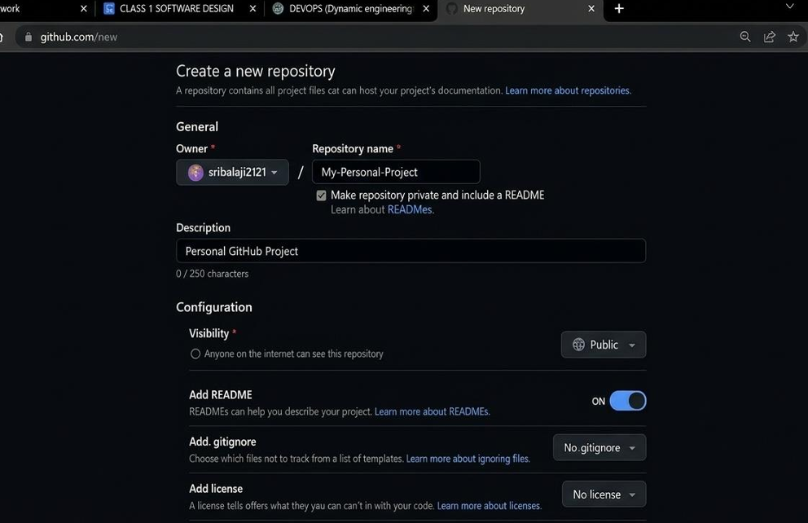
- 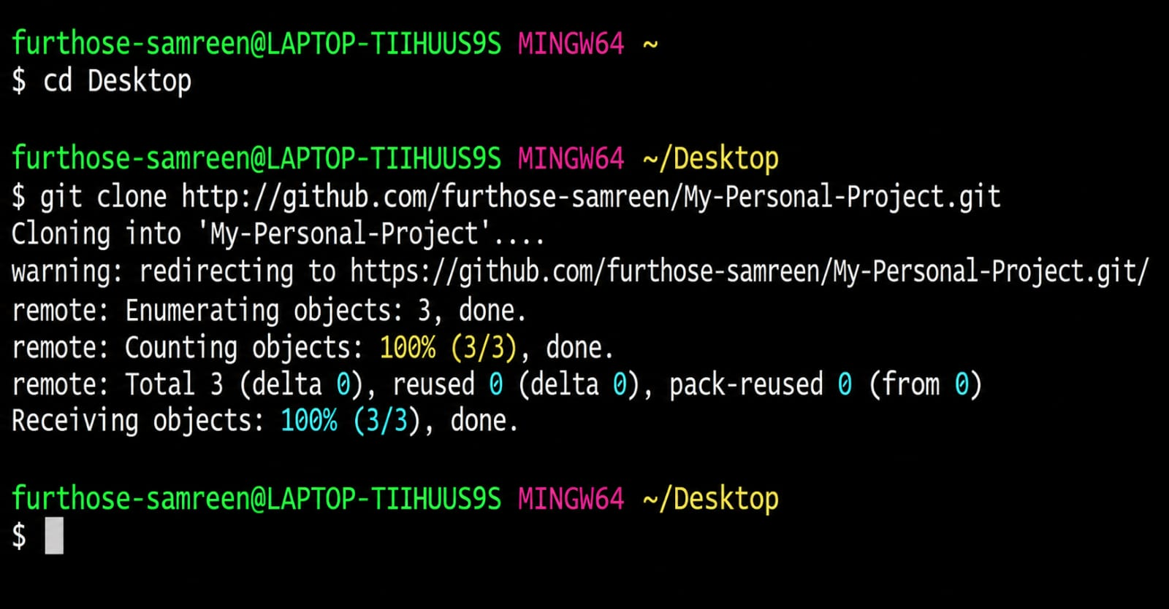

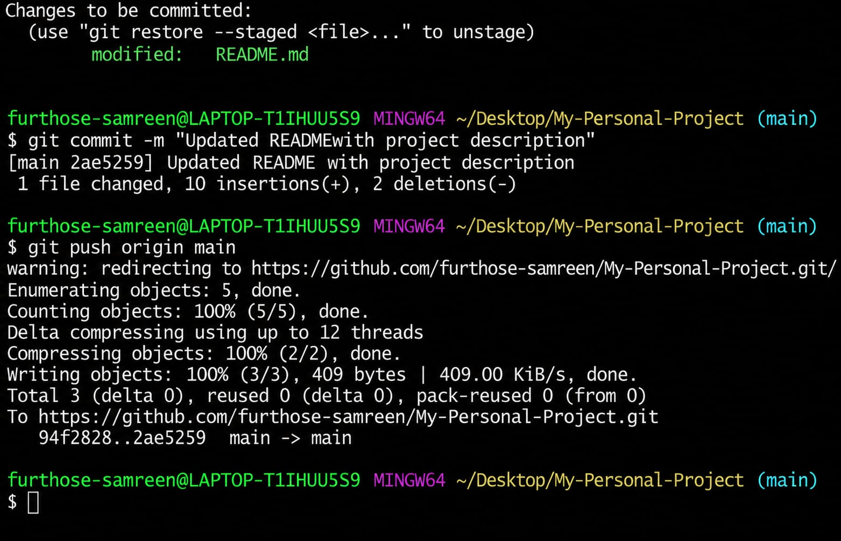
RESULT
Thus, a GitHub repository was successfully created for a team project. Individual branches were created for different modules, changes were committed, pull requests were reviewed and merged, merge conflicts were resolved, and the project workflow was documented using a README file.

https://github.com/192511164simats-source/Software-engineering-

